Staircase
Platform: HackerRank
Language: C
Module 6, Question 1

Problem Link
https://www.hackerrank.com/challenges/staircase/problem

Problem Statement
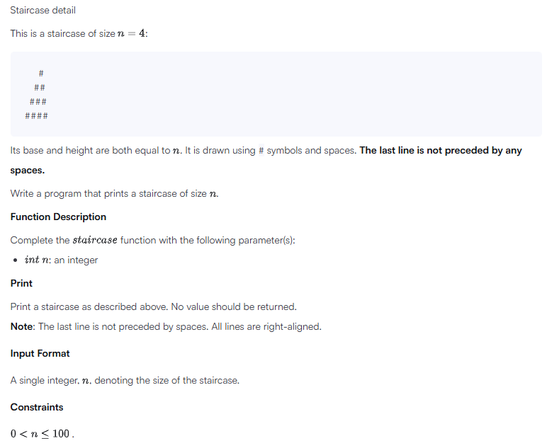

C Code
#include <stdio.h>

int main() {
int n;
scanf("%d", &n);

for (int i = 1; i <= n; i++) {
for (int s = 1; s <= n - i; s++)
printf(" "); // leading spaces
for (int h = 1; h <= i; h++)
printf("#"); // hash symbols
printf("\n");
}
return 0;
}

Screenshot of Successful Submission



